Blues/Soul/R&B/Country Artist
Lomax Spaulding

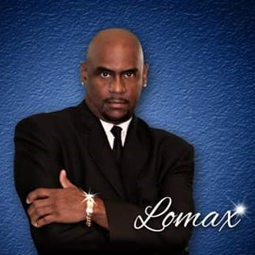

Blues/Soul/R&B/Country Artist
Lomax Spaulding

